# USABILITY TESTING METHODOLOGY

## What happened during the usability test

The usability evaluation of the Handwritten Text Recognition was conducted by Project Team no. 6 comprising of Akshat Chatterjee, Bang Abhishek Deepak, Siddharth Chatterjee, K. Rishita and C. Darshita on 30/05/2021.

During the usability evaluation, 4 participants, matching basic user profiles, were asked to spare at least 10 minutes with our website application, due to time constraints. Attached herewith are the YouTube links to Saksham’s and Raj’s usability testing conducted on Google Meet platform.

Saksham - <https://www.youtube.com/watch?v=WWbpP8p8e8Q>

Raj - <https://www.youtube.com/watch?v=lmaVhGaJm9k>

During these testing, participants:

* Completed a user background questionnaire
* Answered questions about initial site impressions
* Performed real-world tasks on the site while thinking aloud
* Answered questions about their overall satisfaction

## Who we tested

The following participants took part in our usability testing for Handwritten Text Recognition.

Team number

|  |  |  |  |
| --- | --- | --- | --- |
| **NAME** | **REG. NO** | **AGE** | **GENDER** |
| Saksham Dewan | 19BCE2090 | 20 | Male |
| Raj Anand | 19BCE0165 | 20 | Male |
| Royal Sharma | 19BCE2692 | 21 | Male |
| Diyanshu Gupta | 19BCE2093 | 19 | Male |

|  |  |
| --- | --- |
| Women | 0 |
| Men | 4 |
| **TOTAL (participants)** | **4** |

## Where we tested

Following is a summary of the participants’ computing environment:

|  |  |
| --- | --- |
| URL of tested website: | http://127.0.0.1:4555/ |
| Computer platforms: | VS Code, PyCharm, Google Meet |
| Browser tested: | Google Chrome, Brave, Mozilla Firefox |
| Screen resolution: | 1920 x 1080 pixels, Full HD (1080p) |
| Operating system: | Windows OS, Ubuntu (Linux OS), Pop!_OS |
| Connection speed: | 3 Mbps |

The following usability tests (tasks) were identified from user data collection efforts and assistance from the Project Team no. 6 working on Handwritten Text Recognition.

|  |  |
| --- | --- |
| **#** | **Task** |
| 1 | Verify if the web application is completely loading from the run window after the localhost link is generated. |
| 2 | Verify if the landing page of web application has a simple interface for first time users (match heuristic principles) |
| 3 | Verify if simple instructions are given to the user for navigation flow. |
| 4 | Verify if the ‘Add Image’ option changes in color and opacity when the mouse cursor is hovered over it. |
| 5 | Verify if there is a container for ‘Drag and Drop .png file or select/add an image’ |
| 6 | Verify if an ‘upload’ container pops up automatically when initiating previous action. |
| 7 | Verify if there are ‘Recognise’ and ‘Train’ options for Handwritten text recognition or training model. |
| 8 | Verify if there is character recognition for each and every character in the text uploaded, when user clicks ‘Recognise’ option. |
| 9 | Verify if the user is able to hear the audio for the recognized text. |
| 10 | Verify if the user is pleased with the audio delivery and pace for recognized text. |
| 11 | Verify if the user is able to notice the pop ups while uploading image file. |
| 12 | Verify if the user is able to use the shortcuts incorporated by the developers. |
| 13 | Verify if the user is able to confirm that he/she has uploaded the right image file, through ‘Image Uploaded successfully’ pop up and recognize through, ‘Image recognition started successfully’ |
| 14 | Verify if the user is able to understand the fact that he/she cannot upload a file other than png. |
| 15 | Verify if the user is pleased with the output containers from clicking train button, after characters are recognized. |
| 16 | Verify if a very naïve and technologically challenged user is able to access help and documentation in worst case scenario for guidance to use the web application. |

|  |  |  |  |
| --- | --- | --- | --- |
| **Participant 1(19BCE0145, Raj Anand)** | **Passed or failed** | **Time taken** | **Interface is good/bad/ok** |
| Verify if the web application is completely loading from the run window after the localhost link is generated. | Passed | 3s | Good |
| Verify if the landing page of web application has a simple interface for first time users (match heuristic principles) | Passed | 4s | Ok |
| Verify if simple instructions are given to the user for navigation flow. | Failed | 3s | Bad |
| Verify if the ‘Add Image’ option changes in color and opacity when the mouse cursor is hovered over it. | Passed | 2s | Good |
| Verify if there is a container for ‘Drag and Drop .png file or select/add an image’ | Passed | 3s | Good |
| Verify if an ‘upload’ container pops up automatically when initiating previous action. | Passed | 3s | Ok |
| Verify if there are ‘Recognize’ and ‘Train’ options for Handwritten text recognition or training model. | Passed | 5s | Good |
| Verify if there is character recognition for each and every character in the text uploaded, when user clicks ‘Recognize’ option. | Passed | 4s | Good |
| Verify if the user is able to hear the audio for the recognized text. | Passed | 6s | Good |
| Verify if the user is pleased with the audio delivery and pace for recognized text. | Passed | 5s | Ok |
| Verify if the user is able to notice the pop ups while uploading image file. | Passed | 4s | Bad |
| Verify if the user is able to use the shortcuts incorporated by the developers. | Passed | 7s | Ok |
| Verify if the user is able to confirm that he/she has uploaded the right image file, through ‘Image Uploaded successfully’ pop up and recognize through, ‘Image recognition started successfully’ | Passed | 10s | Ok |
| Verify if the user is able to understand the fact that he/she cannot upload a file other than png. | Passed | 5s | Good |

|  |  |  |  |
| --- | --- | --- | --- |
| **Participant 2 (19BCE2090, Saksham Dewan )** | **Passed or failed** | **Time taken** | **Interface is good/bad/ok** |
| Verify if the web application is completely loading from the run window after the localhost link is generated. | Passed | 5s | Good |
| Verify if the landing page of web application has a simple interface for first time users (match heuristic principles) | Passed | 5s | Good |
| Verify if simple instructions are given to the user for navigation flow. | Passed | 7s | Good |
| Verify if the ‘Add Image’ option changes in color and opacity when the mouse cursor is hovered over it. | Passed | 2s | Ok |
| Verify if there is a container for ‘Drag and Drop .png file or select/add an image’ | Passed | 3s | Ok |
| Verify if an ‘upload’ container pops up automatically when initiating previous action. | Passed | 3s | Ok |
| Verify if there are ‘Recognize’ and ‘Train’ options for Handwritten text recognition or training model. | Passed | 5s | Good |
| Verify if there is character recognition for each and every character in the text uploaded, when user clicks ‘Recognize’ option. | Passed | 4s | Good |
| Verify if the user is able to hear the audio for the recognized text. | Passed | 6s | Good |
| Verify if the user is pleased with the audio delivery and pace for recognized text. | Passed | 5s | Good |
| Verify if the user is able to notice the pop ups while uploading image file. | Passed | 4s | Good |
| Verify if the user is able to use the shortcuts incorporated by the developers. | Passed | 7s | Ok |
| Verify if the user is able to confirm that he/she has uploaded the right image file, through ‘Image Uploaded successfully’ pop up and recognize through, ‘Image recognition started successfully’ | Passed | 10s | Ok |
| Verify if the user is able to understand the fact that he/she cannot upload a file other than png. | Passed | 5s | Good |

|  |  |  |  |
| --- | --- | --- | --- |
| Participant 3(19BCE2692, Royal Sharma) | Passed or failed | Time taken | Interface is good/bad/ok |
| Verify if the web application is completely loading from the run window after the localhost link is generated. | Passed | 5s | Good |
| Verify if the landing page of web application has a simple interface for first time users (match heuristic principles) | Passed | 4s | Ok |
| Verify if simple instructions are given to the user for navigation flow. | Failed | 5s | Bad |
| Verify if the ‘Add Image’ option changes in color and opacity when the mouse cursor is hovered over it. | Passed | 5s | Good |
| Verify if there is a container for ‘Drag and Drop .png file or select/add an image’ | Passed | 5s | Good |
| Verify if an ‘upload’ container pops up automatically when initiating previous action. | Failed | 5s | Bad |
| Verify if there are ‘Recognize’ and ‘Train’ options for Handwritten text recognition or training model. | Passed | 4s | Good |
| Verify if there is character recognition for each and every character in the text uploaded, when user clicks ‘Recognize’ option. | Passed | 4s | Good |
| Verify if the user is able to hear the audio for the recognized text. | Passed | 4s | Good |
| Verify if the user is pleased with the audio delivery and pace for recognized text. | Passed | 5s | Ok |
| Verify if the user is able to notice the pop ups while uploading image file. | Failed | 6s | Bad |
| Verify if the user is able to use the shortcuts incorporated by the developers. | Passed | 7s | Ok |
| Verify if the user is able to confirm that he/she has uploaded the right image file, through ‘Image Uploaded successfully’ pop up and recognize through, ‘Image recognition started successfully’ | Failed | 8s | Ok |
| Verify if the user is able to understand the fact that he/she cannot upload a file other than png. | Passed | 2s | Good |

|  |  |  |  |
| --- | --- | --- | --- |
| Participant 4 (19BCE0469, Divyanshu Jain) | Passed or failed | Time taken | Interface is good/bad/ok |
| Verify if the web application is completely loading from the run window after the localhost link is generated. | Passed | 3s | Good |
| Verify if the landing page of web application has a simple interface for first time users (match heuristic principles) | Passed | 4s | Ok |
| Verify if simple instructions are given to the user for navigation flow. | Failed | 3s | Bad |
| Verify if the ‘Add Image’ option changes in color and opacity when the mouse cursor is hovered over it. | Passed | 3s | Good |
| Verify if there is a container for ‘Drag and Drop .png file or select/add an image’ | Passed | 4s | Good |
| Verify if an ‘upload’ container pops up automatically when initiating previous action. | Passed | 4s | Ok |
| Verify if there are ‘Recognize’ and ‘Train’ options for Handwritten text recognition or training model. | Passed | 4s | Good |
| Verify if there is character recognition for each and every character in the text uploaded, when user clicks ‘Recognize’ option. | Passed | 4s | Good |
| Verify if the user is able to hear the audio for the recognized text. | Passed | 7s | Good |
| Verify if the user is pleased with the audio delivery and pace for recognized text. | Passed | 6s | Ok |
| Verify if the user is able to notice the pop ups while uploading image file. | Passed | 3s | Bad |
| Verify if the user is able to use the shortcuts incorporated by the developers. | Failed | 8s | Ok |
| Verify if the user is able to confirm that he/she has uploaded the right image file, through ‘Image Uploaded successfully’ pop up and recognize through, ‘Image recognition started successfully’ | Passed | 9s | Ok |
| Verify if the user is able to understand the fact that he/she cannot upload a file other than png. | Failed | 4s | Good |

## Exit Questions/User Impressions

At the end of each session, we asked participants, the following nine questions. Below each question is the answer provided by some of the participants:

* What is your overall impression to Handwritten Text Recognition web application?

Raj said he was impressed with the simplicity of this application and the conversion rate was very good.

Saksham said it was really good. I liked the objective or aim behind this. And also the simple and easy to walkthrough and wonderful UI altogether.

Royal said it was fantastic and easy to navigate. All the buttons make sense and the containers are good.

Divyanshu was satisfied. Voice recognition was an aspect he liked about.

* What is your impression of the colour scheme?

Raj said that the design and the colours are good, they are not straining the eye too much (hitting it too hard)

The colors are too green, the gradient in the background is breaking, and he said he can notice it.

Saksham was impressed with the color scheme, he had no other feedback.

Royal declined to comment. Divyanshu said it was ok.

* What did you like best about the site?

Raj said that the conversion of text image to voice was the best aspect about the site and it was quite fast, other than being impressive enough and clear in vocals.

Saksham liked the female voice recognition feature as it was soothing.

Royal was impressed with the working of the software and project being executed each time with 0 bugs.

Divyanshu said voice recognition.

* What did you like least about the site?

Raj said that the process of adding a image from the user, that is a bit slow, it could be bettered. No help and documentation for first time users who might not be smart enough to understand the application of the system.

Saksham had no comments.

Royal had no comments.

Divyanshu wanted to use different frameworks for this website application, through java fx, etc.

* If you were the website developer, what would be the first thing you would do to improve the website?

Raj said that the process of adding an image is bit slow, can be improved. He would add more colours as well, to this application. Add a high quality background as well. Make whole thing in React.js so it’s more dynamic and it has server side rendering.

Saksham said that he would like some documentation for the website application, too bland doesn’t look very appealing to him.

No comments from Royal and Divyanshu.

* Is there anything that you feel is missing on this site? (Probe: content or site features/functions)

Raj said that adding more image formats and text could be improved upon. A short description of what the project does could be helpful.

Saksham said a help chat bot could be added to this site.

* If you were to describe this site to a colleague in a sentence or two, what would you say?

Raj said that he would tell his friend upload an image with a text, that would get converted into an audio.

Both Saksham and Royal said that, they would tell his colleague it’s a simple handwritten text recognition software.

* Do you have any other final comments or questions?

Raj appreciated that the whole project was really well done. Later he asked what different languages/frameworks we used, and how we proceeded with the project.

Saksham didn’t have any final comments/questions.

Royal asked us to show the code editor with the various libraries and frameworks in use and being imported.

**Metrics**

* **No. of test cases planned vs. executed**

Total test cases planned = 40 (25 unit tests + 15 usability tests)

Total test cases executed = 38

Total test cases passed = 35

Total test cases failed = 3

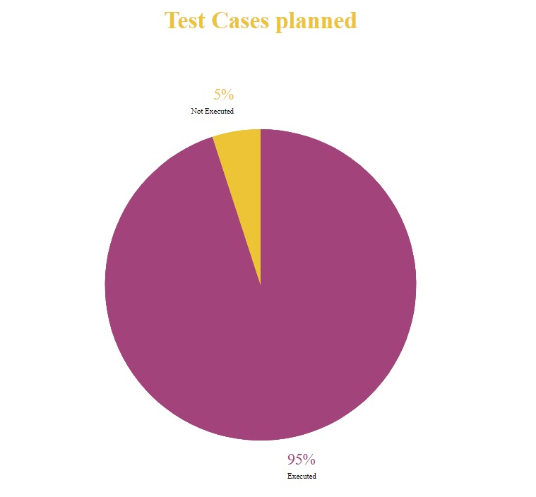

* **No. of test cases passed/failed**

Total test cases planned = 40 (25 unit tests + 15 usability tests)

Total test cases executed = 38

Total test cases passed = 35

Total test cases failed = 3

